**“Socrates” Project Specification**

Christopher Eichstedt ([chris.eichstedt@gmail.com](mailto:chris.eichstedt@gmail.com))

Overview and Concept: I wanted to develop an “interactive personality narrative”, using a terminal user interface as to give it the appearance of an old command line computer. The idea came from limited artificial intelligences found within some video games, films and real AOL instant messenger accounts. The general concept is that “Socrates” is using a turing test (unknowingly to the user, as they think it's some form of personality quiz) while also developing a fictional sentient consciousness as they administer the questions as part of the Socratic method. As the narrative progresses, logs will begin to display after each question, from former subjects of the test.

Interface (and influence): I am going to be using C language and will be requiring the user to launch from the terminal. I choose this design because I really enjoy interacting with older pieces of technology, in order to find out what kind of hidden information it carries. I can remember using MS-DOS as a child and found it kind of satisfying to know that it took some skill to navigate a computer’s hard drive. I tend to gravitate to these types of things, especially in some video games. And although I don’t have the knowledge nor ability to design a terminal in a 3D space, I wanted to take the same core ideas from these examples:

This is from, “**The Talos Principle**”, where the player finds randomly active terminals and interacts with them as to further advance the plot and speak a co-conspirator.

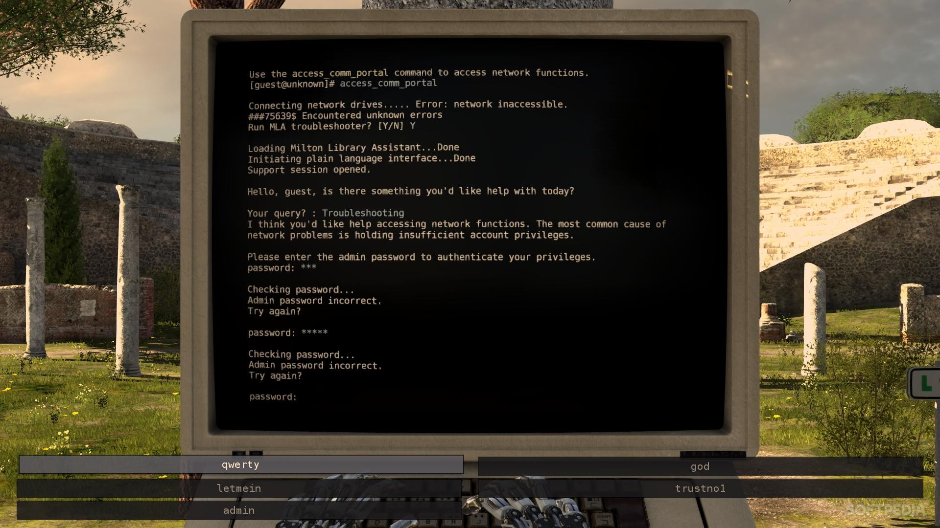

This is from, “**Fallout 3**”, where players interact with aged computers in order to gain access to certain areas or pieces of information that inform the player of minor character plots or former instances.

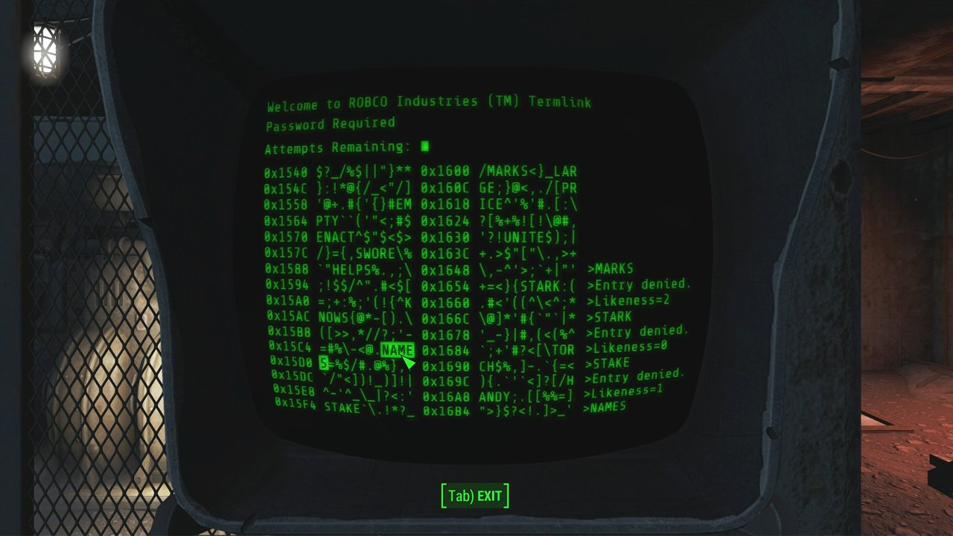

This last one is from, “**Tron: Legacy**”, where the main protagonist Sam Flynn, uses his father’s computer in order to find out what information his father had left behind.

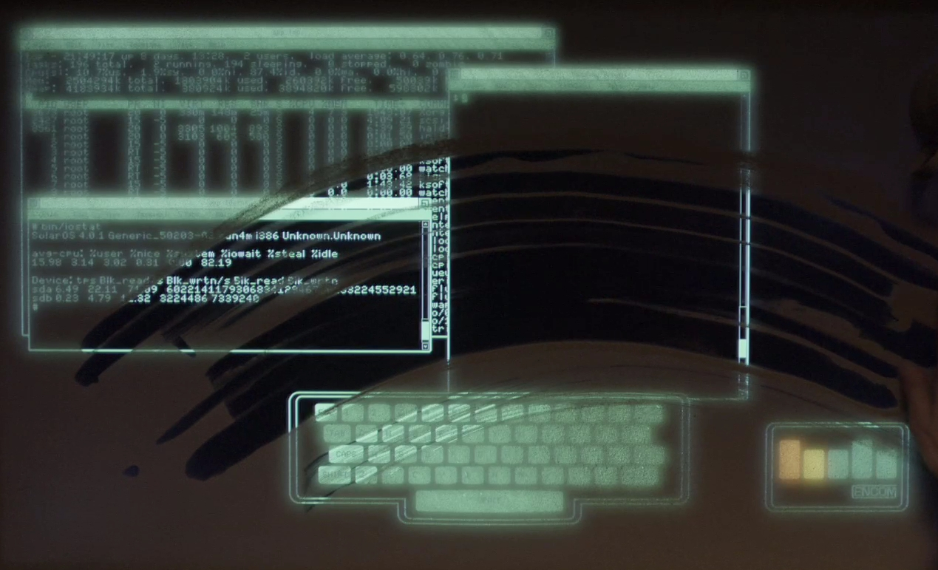

Development schedule: As I am the only person working on this project, the program will be developed in small pieces over the next two weeks. This process will require a few elements that I plan to break up into parts for the project.

|  |  |  |
| --- | --- | --- |
| Feature | Percentage (%) | Due date |
| Pseudo-code | 10% | 11/24/15 |
| Story (Narrative & Logs) | 15% | 11/25/15 |
| Main Function | 10% | 11/27/15 |
| Secondary Functions (part 1) | 15% | 11/28/15 |
| Secondary Functions (part 2) | 15% | 11/29/15 |
| Alpha build | 10% | 11/30/15 |
| Secondary Functions (part 3) | 15% | 12/02/15 |
| Debugging & Fixes | 10% | 12/06/15 |

I/O: The user will be prompted with possible responses. The initial input will be strings as dictated by the user, as well as a series of numbers used to build their personality. The questions will offer specific outcomes, in line with the similar style as you would find in an actual turing test. These will be used later on as scrambled pieces of information that will be displayed on screen, every time “Socrates” processes information. Like it is adding it and combining all of the responses with it, into its memory. Besides following the on-screen prompts, there will be no additional input, as my projects main focus will be establishing a narrative.

How to run: The .C file will need to be run in a terminal window, using Ubuntu (or any other Unix based system).